
American Vacuum Company Equipment Data Sheet
American Vacuum Co. Equipment Data Sheet

Air Operated Vacuum Cleaners
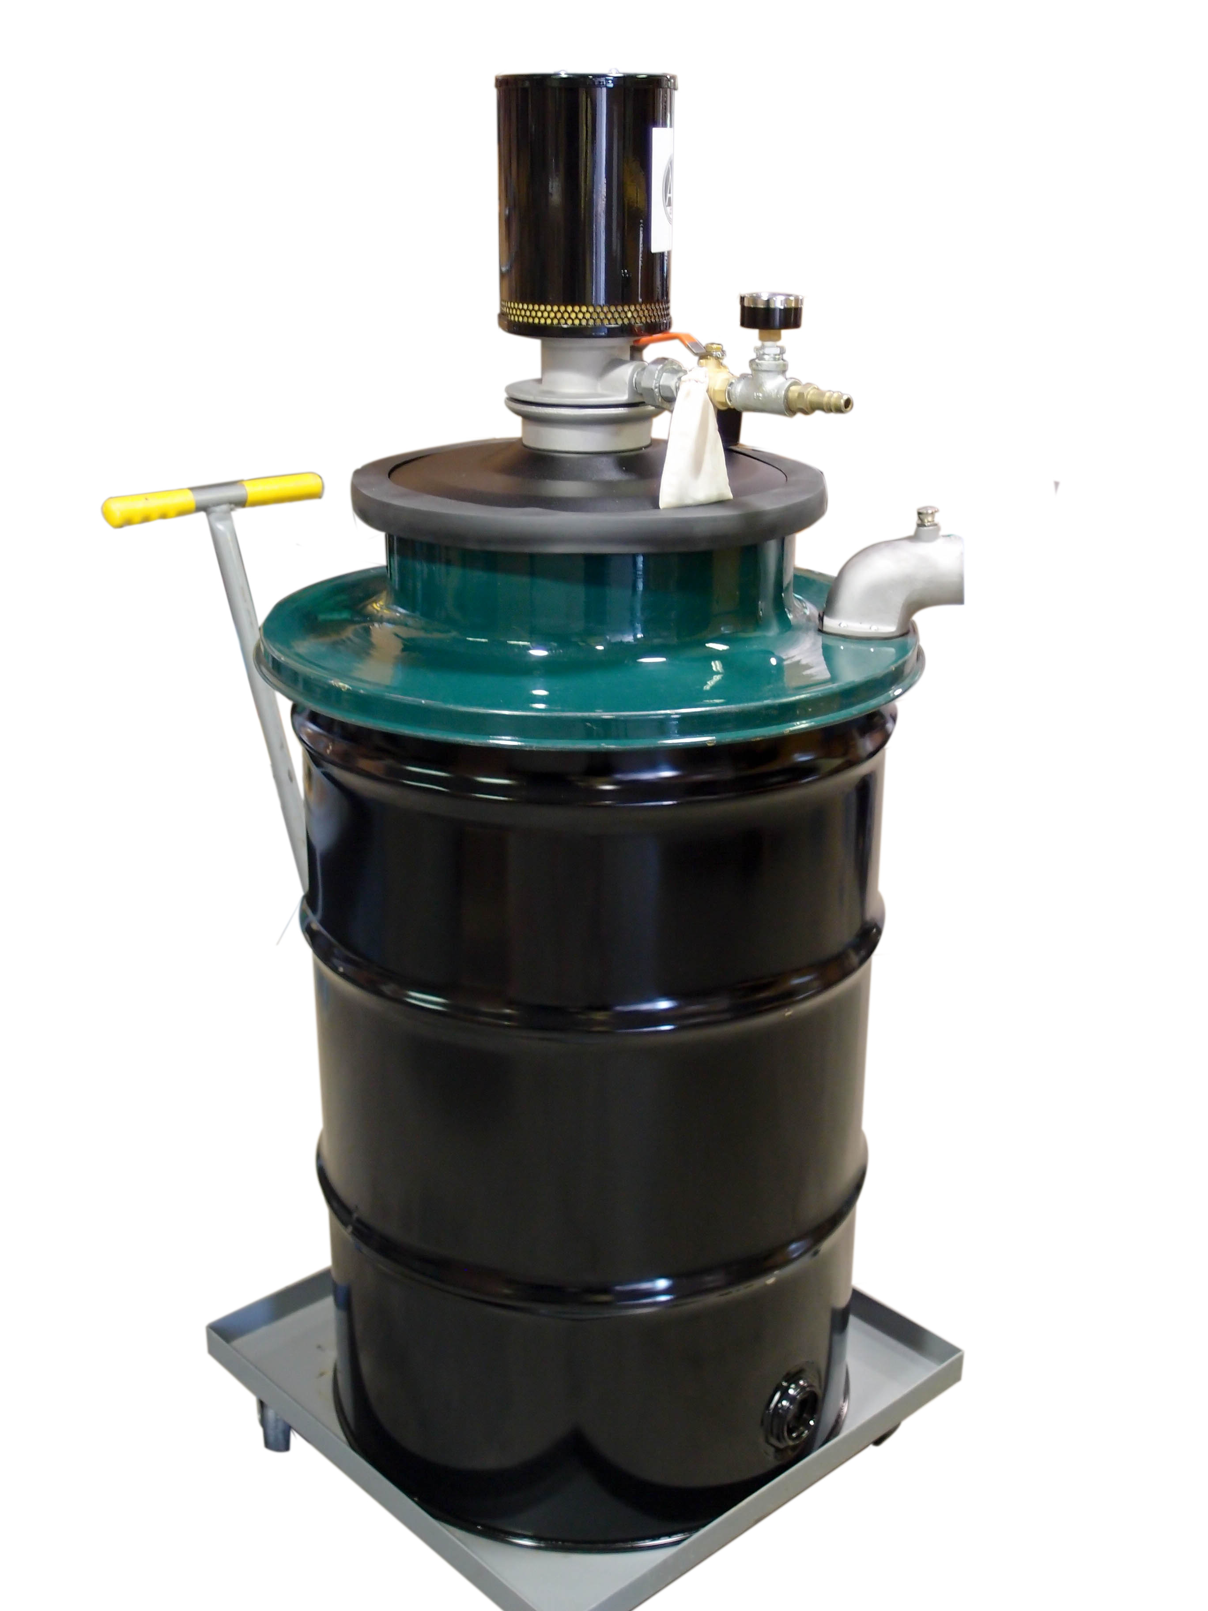

55 Gallon Series Model Specific Features:
Model | 1J55
Tank Size | 55 gallon
Suction CFM | 145 CFM
Static Lift H20/ Hg | 180” H20/ 13”HG
Input PSI | 90PSI
Input CFM | 40 CFM
Wet / Dry Recovery | Yes
Tank Material | Painted Steel
Weight | 140lbs.

AMHose and Cleaning Tools ● Central Vacuum Tube and Fittings ● Custom Controls

AMERICAN VACUUM, 7301 N. MONTICELLO AVE, SKOKIE, IL 60076
TOLL FREE: 800-321-2849 FAX: 847-674-0214
www.americanvacuum.com Email: sales@americanvacuum.com

55 Gallon Air Operated Vacuum
Our 55 Gallon wet/dry air operated vacuum cleaner
is the ideal unit for tough clean up jobs. With no moving
parts you can run the machine continuously. These
units are non-electric and ideal for hazardous dust !!
Filter systems are grounded assuring you of spark free
operation.

Air Operated Series Common Features:
- 2-Stage filter system efficient to 1 Micron
- Oversized wheels and casters for increased mobility
- 55 Gallon Painted Steel Tank
- Quite Operation under 80 DBA
- Washable “Tetra-Tec main filter
- 2 Tank set-up (see picture below)
- Grounded Hose & Cleaning tools
- Unit shipped with 3 different air jet sizes
- PSI Gauge standard on all units
- Incredibly easy to replacement muffler insert
Optional Features:
- 55 Gallon drum transfer lids for additional capacity
- ULPA/HEPA Filters available
- Nomex Hi-Temp filters available
- Complete selection of 1¼” , 1½” and 2” attachments
- External Filter option
- Vacuum gauges & manometers are available
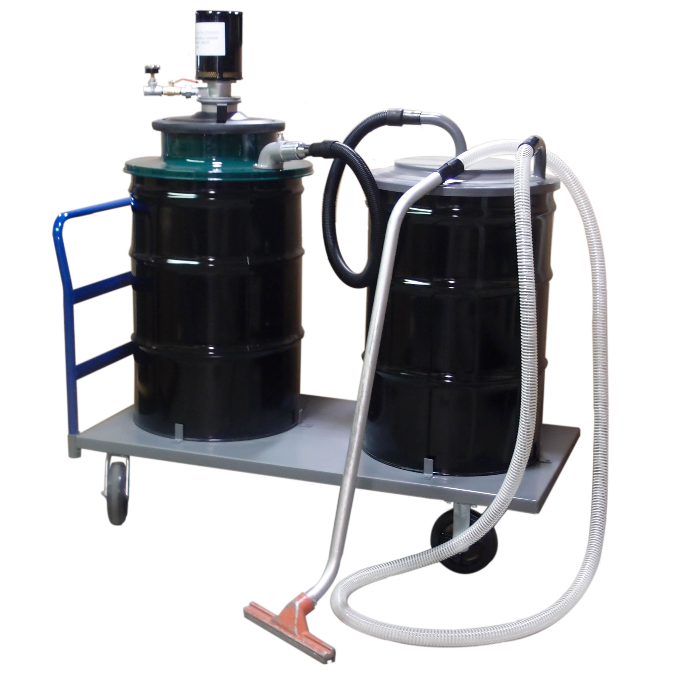

AMERICAN VACUUM, 7301 N. MONTICELLO AVE, SKOKIE, IL 60076
TOLL FREE: 800-321-2849 FAX: 847-674-0214
www.americanvacuum.com Email: sales@americanvacuum.com

