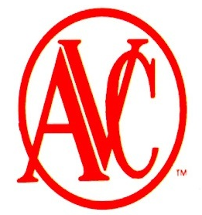
American Vacuum Company Equipment Data Sheet
American Vacuum Co. Equipment Data Sheet

Air Operated Vacuum Cleaners | 18 Gallon Air Operated Vacuum
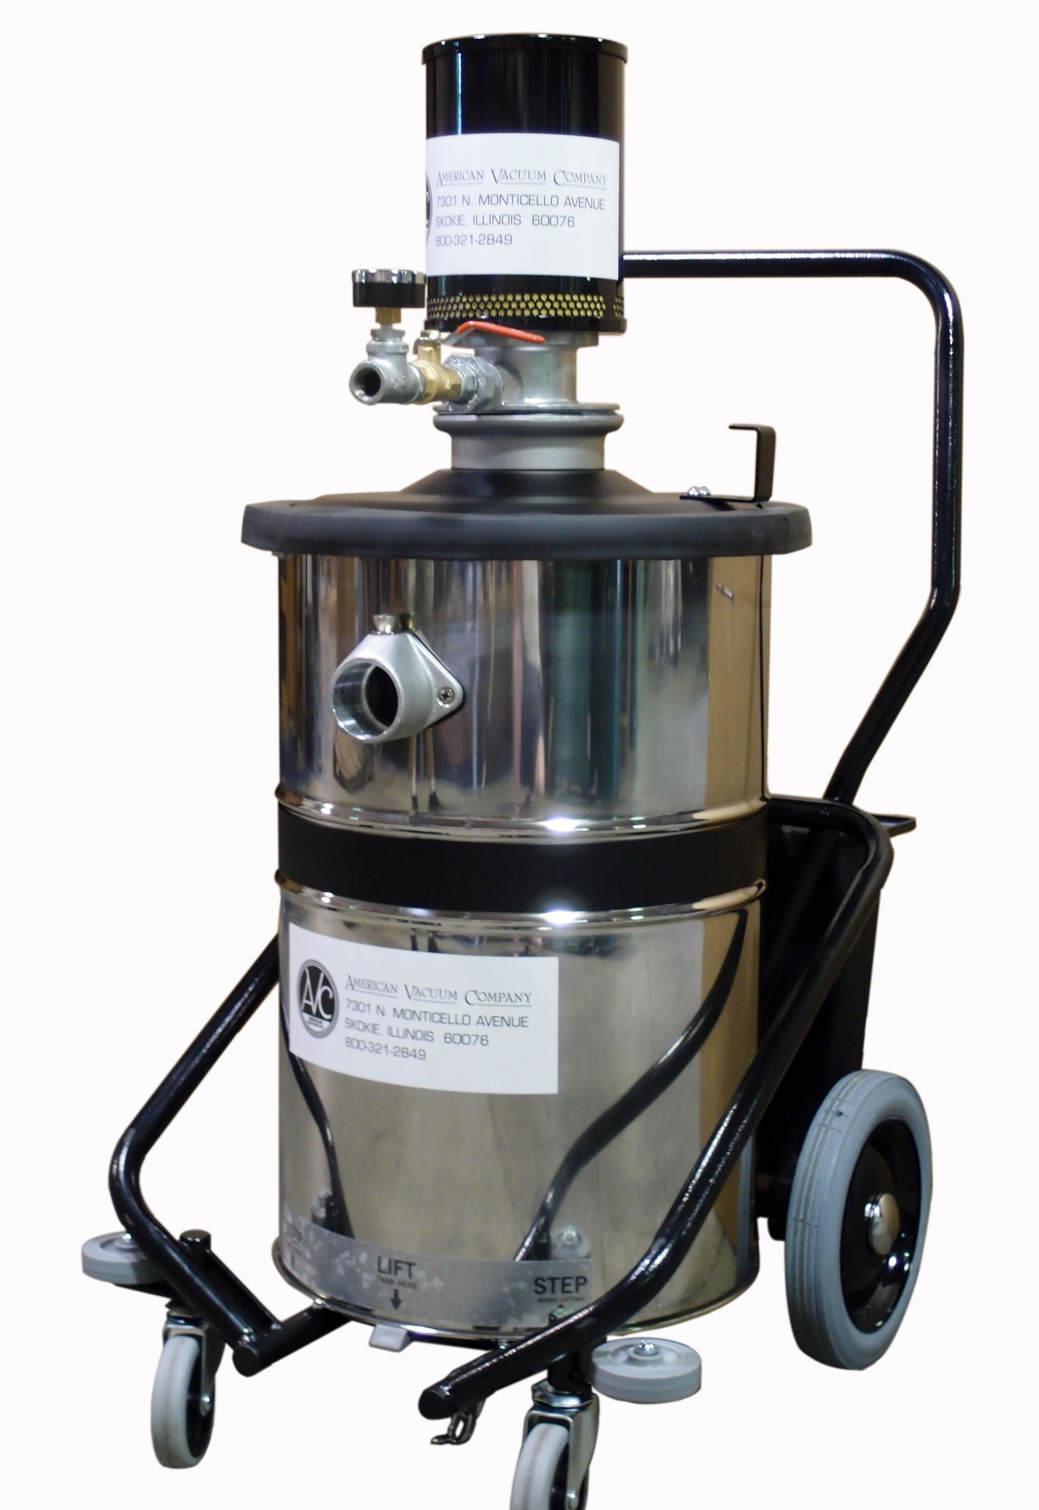 | Our 18 Gallon wet/dry air operated vacuum cleaner is the ideal unit for tough clean up jobs. With no moving parts you can run the machine continuously. These units are non-electric and ideal for hazardous dust !! Filter systems are grounded assuring you of spark free operation.  Air Operated Series Common Features:  - 2-Stage filter system efficient to 1 Micron  - Oversized wheels and casters for increased mobility  - 18 Gallon Stainless Steel, Non-Sparking Tank  - Quite Operation under 80 DBA  - Washable “Tetra-Tec main filter  - Unique Tip & Pour tank (see picture below)  - Grounded Hose & Cleaning tools  - Unit shipped with 3 different air jet sizes  - PSI Gauge standard on all units  - Incredibly easy to replacement muffler insert  Optional Features:  - 55 Gallon drum transfer lids for additional capacity  - ULPA/HEPA Filters available  - Nomex Hi-Temp filters available  - Complete selection of 1¼” , 1½” and 2” attachments  - External Filter option  - Vacuum gauges & manometers are available
18 Gallon Series Model Specific Features:  American Vacuum Company offers the complete engineered solution for YOUR specific application. Contact us directly at (800) 321-2849 to discuss your specific application. | 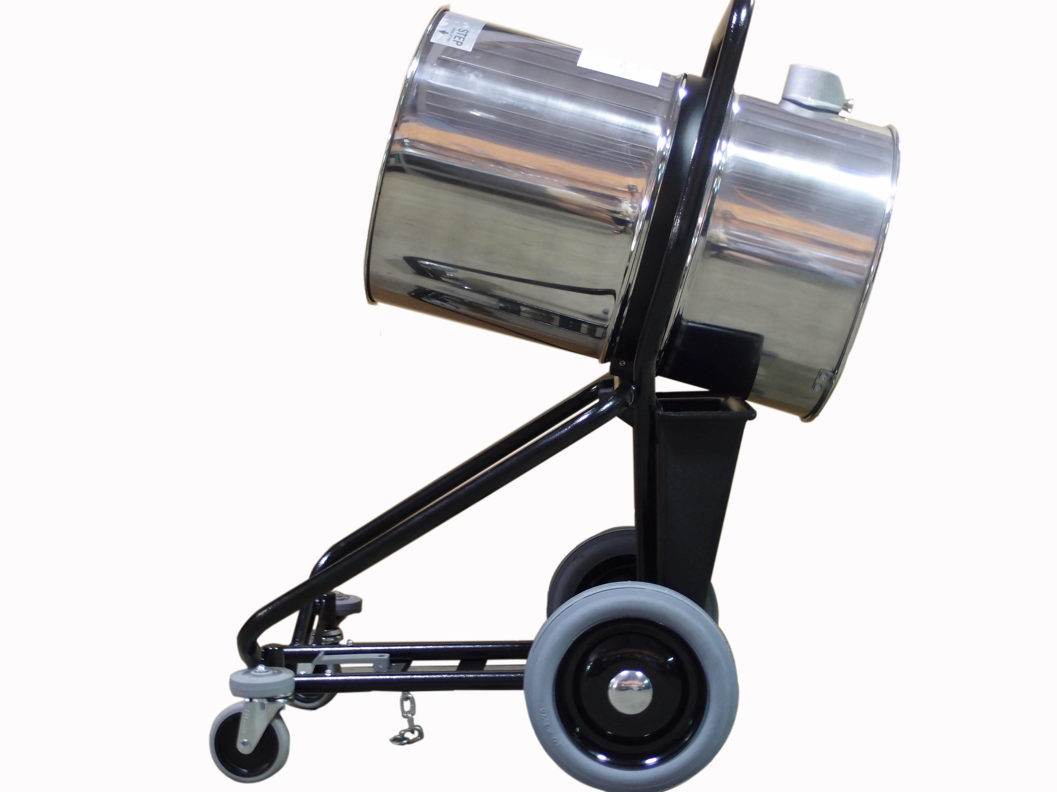
  Model | 1J18
  Tank Size | 18 gallon
  Suction CFM | 145 CFM
  Static Lift H20/ Hg | 180” H20/ 13”HG
  Input PSI | 90PSI
  Input CFM | 40 CFM
  Wet / Dry Recovery | Yes
  Tank Material | Stainless Steel
  Weight | 60lbs.
Hose and Cleaning Tools ● Central Vacuum Tube and Fittings ● Custom Controls
AMERICAN VACUUM, 7301 N. MONTICELLO AVE, SKOKIE, IL 60076
TOLL FREE: 800-321-2849 FAX: 847-674-0214
www.americanvacuum.com Email: sales@americanvacuum.com

